Lab – Ansible Inventory File
In this lab, you will learn how to create and use Ansible inventory files.
An inventory file tells Ansible which systems to manage and how to connect to them. With a single command, you can target and automate tasks across multiple hosts.

Learning Objectives
By the end of this lab, you will be able to:
- Create an inventory file for Ansible projects.
- Understand inventory syntax in INI and YAML.
- Add host aliases for readability.
- Configure SSH details (key-based and password-based) in the inventory file.

Pre-Requisites
- Ansible installed on a control node.
- Basic understanding of INI and YAML syntax.
- At least two Linux VMs (managed nodes) with SSH enabled.
Tip: If you know Terraform, you can use it to provision your VMs.

1. Inventory File in INI Format
- Verify SSH Access
From your control node, manually SSH into each managed VM at least once.
This ensures the VMs are added to the known hosts list.
Create a Project Folder
mkdir ansible_project && cd ansible_project

Create an Inventory File
Add the following content to inventory.ini:
Note - Replace these IP addresses with your virtual machine IP address

[webservers]
20.71.160.229
20.71.160.223
[webservers] > defines a group.
Each line under it is a host (IP or FQDN).
Verify the File

ansible-inventory -i inventory.ini --list

2. Inventory File in YAML Format
Create inventory.yml:
all:
children:
webservers:
hosts:
20.71.160.229:
20.71.160.223:

Explanation:
- all: is the top-level group.
- children: groups hosts by category.
- webservers: is a subgroup that lists your hosts.
Verify:
ansible-inventory -i inventory.yml --list

3. Using Aliases for Hosts
Remembering IPs is difficult. Let’s add aliases.

INI Example
[webservers]
backend_vm ansible_host=20.71.160.229
frontend_vm ansible_host=20.71.160.223

YAML Example
all:
children:
webservers:
hosts:
backend_vm:
ansible_host: 20.71.160.229
frontend_vm:
ansible_host: 20.71.160.223

Verify with:
ansible-inventory -i inventory.ini --list

4. Adding SSH Details (Key-Pair Authentication)
Copy your private key into the project folder and secure it:
chmod 400 key.pem
- If using Azure VMs, transfer the key with scp.
Update inventory.ini:
[webservers]
backend_vm ansible_host=20.71.160.229 ansible_user=azureuser ansible_ssh_private_key_file=./key.pem
frontend_vm ansible_host=20.71.160.223 ansible_user=azureuser ansible_ssh_private_key_file=./key.pem

Update inventory.yml:
all:
children:
webservers:
hosts:
backend_vm:
ansible_host: 20.71.160.229
ansible_user: azureuser
ansible_ssh_private_key_file: "./key.pem"
frontend_vm:
ansible_host: 20.71.160.223
ansible_user: azureuser
ansible_ssh_private_key_file: "./key.pem"
- Verify connectivity:
ansible webservers -m ping -i inventory.ini

3. If you see Python warnings, specify the interpreter path:

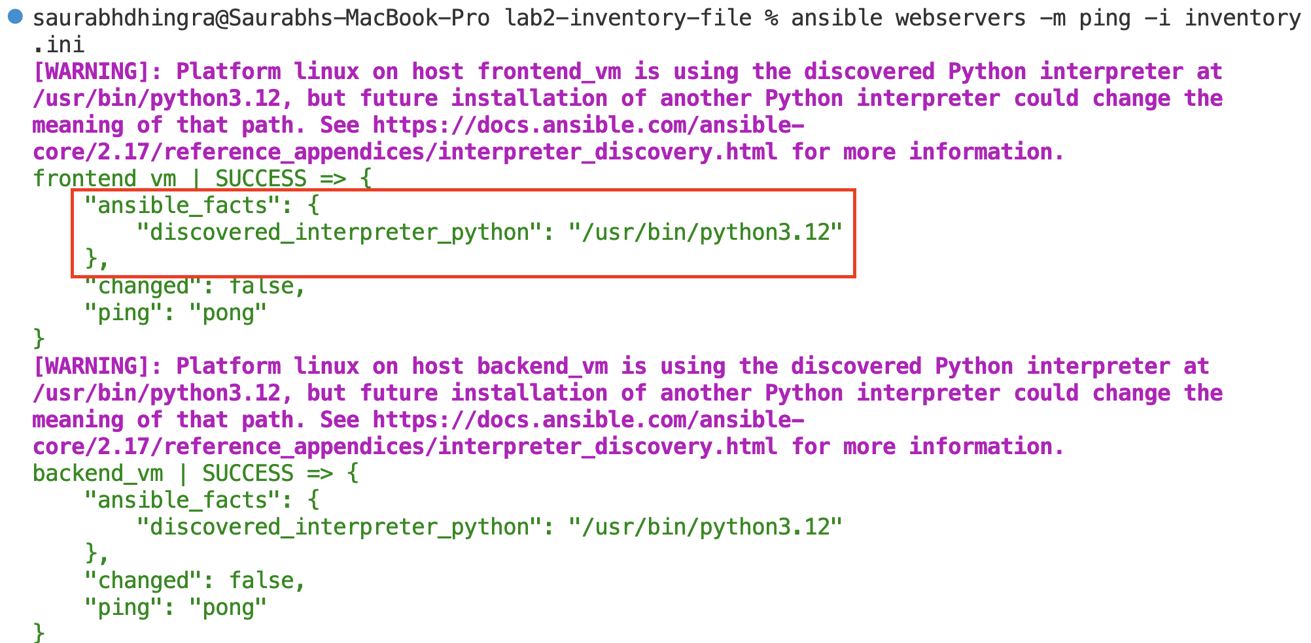
backend_vm ansible_host=20.71.160.229 ansible_user=azureuser ansible_ssh_private_key_file=./key.pem ansible_python_interpreter=/usr/bin/python3.12

5. Adding SSH Details (Username & Password)
If you prefer password-based authentication:

INI Example
[webservers]
backend_vm ansible_host=20.71.160.229 ansible_user=azureuser ansible_ssh_pass=yourpassword ansible_python_interpreter=/usr/bin/python3.12
frontend_vm ansible_host=20.71.160.223 ansible_user=azureuser ansible_ssh_pass=yourpassword ansible_python_interpreter=/usr/bin/python3.12

YAML Example
all:
children:
webservers:
hosts:
backend_vm:
ansible_host: 20.71.160.229
ansible_user: azureuser
ansible_ssh_pass: yourpassword
frontend_vm:
ansible_host: 20.71.160.223
ansible_user: azureuser
ansible_ssh_pass: yourpassword
Verify SSH connection:
ansible webservers -m ping -i inventory.yml

Lab Summary
In this lab, you learned:
- How to define inventory files in INI and YAML formats.
- How to add host groups and aliases.
- How to configure SSH authentication (key-pair and password).
- How to verify connectivity with ansible-inventory and ansible -m ping.

